Caleb Elliott CS 561 HW 7

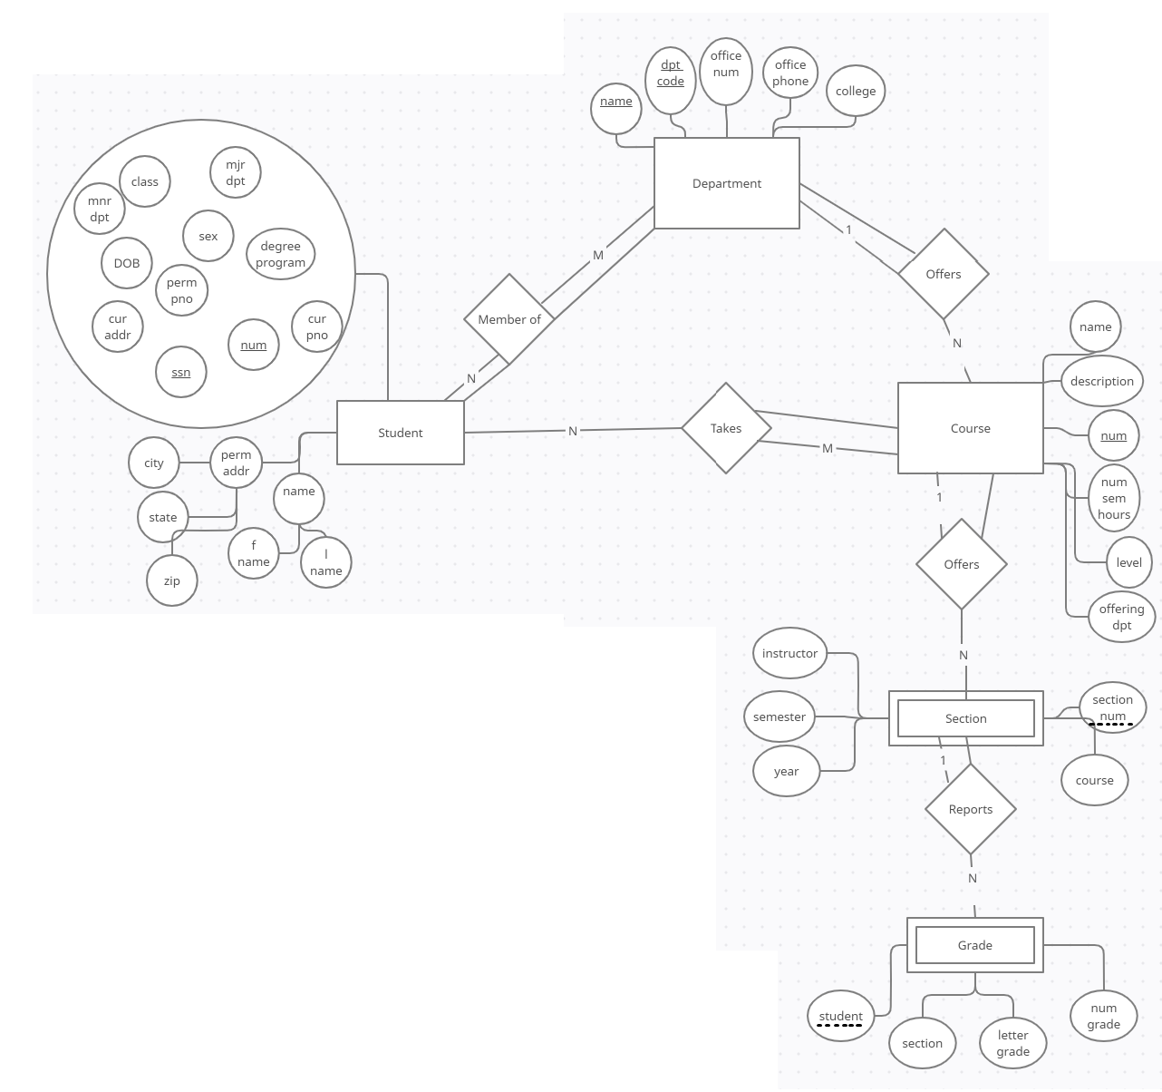

2

1. BANK, ACCOUNT, CUSTOMER, LOAN
2. BANK_BRANCH. Partial key: Branch no. Identifying relationship: BANK
3. {BANK.code, BANK_BRANCH.Branch no} (very unsure what’s being asked for this one)